**Work Up for the Patient with a Bleeding Diathesis**

**Clinical Features**

|  |  |  |
| --- | --- | --- |
| **Bleeding symptoms** | **Bleeding disorder** | |
| Platelet defects (qualitative or quantitative) | Clotting factor deficiencies (eg, factor VIII or factor IX deficiencies) |
| Overview of bleeding events | Mucocutaneous bleeding     (oral cavity, nasal, gastrointestinal, and genitourinary sites) | Deep tissue bleeding     (including joints and muscles) |
| Excessive bleeding after minor cuts | Yes | Not usually |
| Petechiae | Common | Uncommon |
| Ecchymoses | Generally small and superficial; may be significant, depending upon the defect or degree of thrombocytopenia | May develop large subcutaneous and soft tissue hematomas |
| Hemarthroses, muscle hematomas | Uncommon | Common in severe deficiency states or in association with injury in those with mild to moderate deficiency states |
| Bleeding with invasive procedures, including surgery | Often immediate, with degree of bleeding dependent upon the severity of the defect, ranging from none (eg, mild degrees of thrombocytopenia or mild platelet function defect) to mild to severe (eg, Glanzmann thrombasthenia) | May be associated either with procedural bleeding or delayed bleeding, depending upon the type and severity of the defect |

**Work Up**

* Take Home
  + CBC, PT and aPTT, and fibrinogen to start in patients with a bleeding history
    - If all those are normal, consider Platelet Function Analyzer-100
      * which checks the amount of time it takes platelets to aggregate onto an aperture coated with a collagen/epinephrine membrane and a collagen/adenosine diphosphate membrane
        + Is there a prolonged aggregation time with both membranes?

Yes: Evaluate for von Willebrand's disease

No: If prolonged aggregation time is found only with the collagen/epinephrine membrane, look for drug effect, such as from aspirin

If neither are prolonged, further evaluation is warranted, based on clinical suspicion

* + - If PTT is abnormal and PT nl
      * PTT mixing study
        + Does partial thromboplastin time correct (normalize)?

Yes: Factor VIII, IX, and XI assays.

If factor VIII low, work-up for von Willebrand's disease

No: Screen for inhibitors (lupus anticoagulant and factor VIII inhibitor)

* + - * Our lab
        + First does a Thrombin time to r/o heparin and direct thrombin inhibitor

If abnormal

Reptilase time

If normal

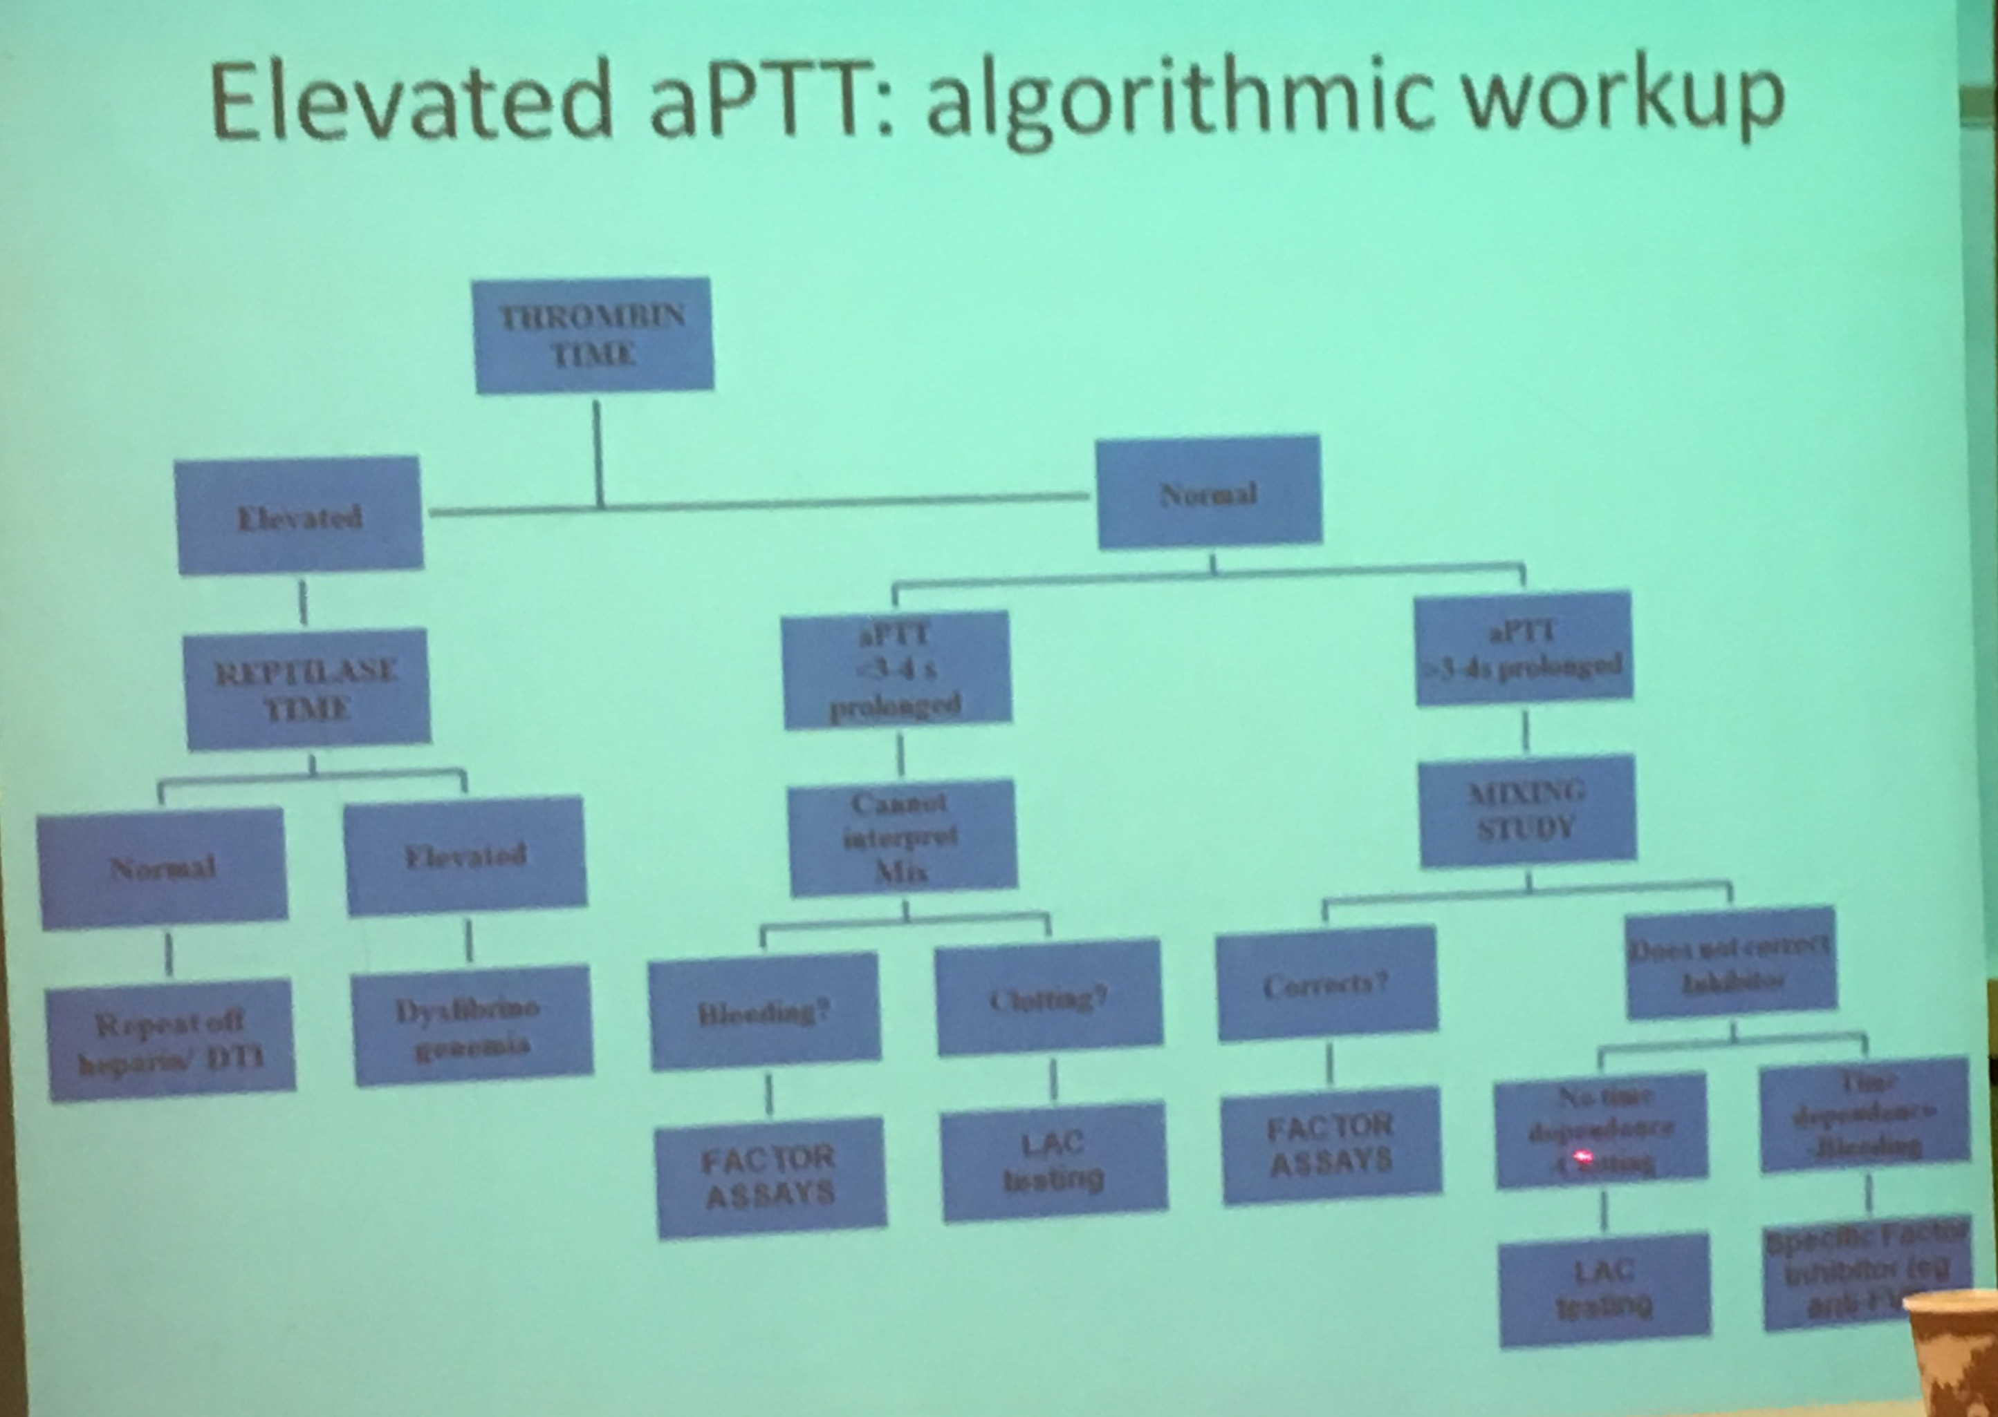

* + - * If you suspect LAC, but the tests are negative
        + Can test factors

Test Factor XI

* + - If PT is abnormal and PTT nl
      * Determine if the patient is malnourished or if there is clinical suspicion for vitamin K deficiency
      * Does prothrombin time correct or normalize with administration of vitamin K?
        + Yes: Replace vitamin K as needed
        + No: Factor assay for factor VII
    - If both PTT and PT are abnormal
      * Consider disseminated intravascular coagulopathy
      * Verify no use of warfarin (Coumadin) or heparin
      * Verify no liver disease
      * Next Step
        + Consider factor assays for factor deficiencies
* **PT and aPTT**
  + For patients who have a convincing bleeding history and normal PT and aPTT testing, it is important to evaluate the possibility of a platelet disorder; this is especially true for patients with a mucocutaneous bleeding pattern
  + The first step is measurement of the **platelet count**
* **Bleeding time**
  + The bleeding time (BT) is a measure of the interaction of platelets with the blood vessel wall
  + A prolonged bleeding time may occur in thrombocytopenia (platelet count usually below 50,000/microL), qualitative platelet abnormalities (eg, uremia), von Willebrand disease (VWD), some cases of vascular purpura, and severe fibrinogen deficiency, in which it is probably the result of platelet dysfunction
  + Among patients with a normal platelet count who are not taking aspirin, the bleeding time is used primarily to screen patients for *inherited disorders of platelet function*
  + An abnormal test in a patient with mucocutaneous bleeding would justify further testing for platelet dysfunction or specific tests for von Willebrand disease (VWD)
  + However, a normal value for the BT should not preclude testing for VWD
  + A normal BT does not predict the safety of surgical procedures, nor does an abnormal BT predict for excessive bleeding
  + Since assessment of the BT is subject to considerable variation due to technical factors in executing the test, a normal range for the test varies from laboratory to laboratory, and cannot be generalized here
  + Of importance, the BT is **not recommended** as a preoperative screening test
  + Because of considerable variation due to technical factors in executing the test, the BT plays a limited role, if any, in evaluating hemostatic defects
* **Prothrombin time**
  + The production of fibrin via the extrinsic pathway and the final common pathway (common to both extrinsic and intrinsic cascades) requires tissue thromboplastin (tissue factor), factor VII (extrinsic pathway), and factors X, V, prothrombin (factor II), and fibrinogen
  + The functioning of these pathways is measured by the plasma prothrombin time
  + The test bypasses the intrinsic pathway and uses thromboplastins to substitute for platelets. Within this combined pathway, factors VII, X, and prothrombin are vitamin-K dependent and are altered by warfarin
  + For this reason, the PT is used as a measure of the anticoagulant activity of warfarin and other vitamin K antagonists
* **Thrombin time and reptilase time**
  + **The thrombin time (TT**) and reptilase time (RT) measure conversion of fibrinogen to fibrin monomers and the formation of initial clot by thrombin and reptilase, respectively.
  + Reptilase, a thrombin-like snake enzyme, differs from thrombin by generating fibrinopeptide A but not fibrinopeptide B from fibrinogen and by resisting inhibition by heparin via antithrombin
  + Fibrin strand cross-linking, which is mediated by factor XIII, is not measured by these assays
  + Prolonged thrombin times and reptilase times may be due to *hypofibrinogenemia*, structurally abnormal fibrinogens (*dysfibrinogens*), or *increased fibrin split products*
  + Since heparin prolongs the TT but not the RT, the RT is useful for determining if heparin is the cause of a prolonged TT
  + Alternatively, one can test for heparin activity via its anti-factor Xa activity, or with the use of a commercial heparinase
* **Urea Clot Test**
  + Factor XIII Deficiency
    - Factor XIII deficiency (FXIII), an extremely rare disorder with a reported prevalence of one in one million in the homozygous state
    - It is extremely important to diagnose it promptly because these patients tend to develop intracranial hemorrhages
    - All coagulation screening laboratory tests are normal even in the presence of FXIII levels that are < 1%
    - Therefore, if the disorder is suspected, the urea clot test (a screening test for this deficiency) should be sent
    - Ideally, the deficiency should be confirmed with measurement of the FXIII antigen by an enzyme-linked immunosorbent assay (ELISA) test
    - FXIII infusions in the form of cryoprecipitate or plasma-derived product should be infused for the treatment of FXIII-related bleeding
    - Patients should be treated prophylactically with factor concentrates monthly infusions (FXIII half-life = 9-14 days)
* **Factor Assessment**
  + Factor Levels can be used to help distinguish between:
    - Liver Dz vs. Vit K Deficiency
      * Measure Factor V
      * Factor V is made in the liver, thus will be low in liver dz, but is not vit K dependent
        + Thus, a normal Factor V and low II, VII, IX, X if indicative of Vit K deficiency
    - In addition, factor levels can be used to assess if a Coagulopathy is due to Liver Disease
      * Increased Factor VIII
        + In liver disease, all the factors are low, except Factor VIII, which is made by the endothelial cells
        + In addition, good hepatic function is required for factor VIII clearance, thus, factor VIII levels are increased in liver disease
* Assess for Medications
  + SSRIs
  + Antiplatelets

